**Module 6: The True Understanding of Blessing (Payoff, Favor and Blessing)**

In the last three sessions we tried to understand the concept of Payoff and Favor through the lives of Ruth, Ahab, Hezekiah and Eli. We have gone through life of Abraham, Ruth and Paul’s to understand what is real blessing and keys to open the doors of blessing.

* Payoff is what we get for our work or acts and Favor is what we get by our nature (humble, meak, sincere, etc.).
* Our pay cheques are not measure for our relationship with God
* Our payoff can be altered by Favor of people and God
* The concept of Grace & Karma
* Blessing comes from heaven and comes with joy.
* Keys to open the doors of blessing: Complete surrender, Faithfulness, Standing as living testimony for God

Let’s come to our today’s session, The concept of Covenant.

**Session 6.4: The concept of Covenant**

**Covenant:** A promise to somebody, or a legal agreement, especially one to pay a regular amount of money to somebody/something (Dictionary).

Covenant is literally a contract.

According to the Bible it is an agreement between God and his people, in which God makes promises to his people and, usually, requires certain conduct from them. In the Old Testament, God made agreements with Noah, Abraham, and Moses .

Covenant itself is a topic for bible study as it is the key theme in the Bible from Genesis to Revelation and it is central point to God's redemptive plan for mankind. Covenant establish the basis of relationship, including the promises and conditions of that relationship, and the consequences if those conditions are not met.

Covenants can be conditional or unconditional. Conditional covenants require at least one party to uphold certain conditions, while unconditional covenants have no stipulations.

Bible has many covenants and the five paramount covenants that God has made are:

* + **Noahic Covenant**: God promises to that he will never again destroy the Earth with a flood. Its unconditional. Genesis 9:8-17 The covenant of rainbow

**Vs 17** And God said to Noah, “This [rainbow] is the sign of the covenant (solemn pledge, binding agreement) which I have established between Me and all living things on the earth.”

* + **Abrahamic Covenant**: God promises to make Abraham the ancestor of a great nation, but Abraham must go to the place God shows him and seal the covenant by circumcision. Its conditional Genesis 17:1-14
  + **Mosaic Covenant**: God promises to provide protection and blessings to the Israelites, but the Israelites must uphold a law code and worship God. Its conditional Exodus 19:1-6
  + **Davidic covenant**: God promised that David’s lineage would last forever and that his kingdom would never pass away permanently (verse 16). Obviously, the Davidic throne has not been in place at all times. 2 Samuel 7:8-16
  + **Ultimate covenant**: The new covenant by Jesus Christ for the redemption of mankind. Its unconditional.

Some other important covenants made by humans include

* Ahimelech made with Abraham and Isaac for their safety
* Abraham made with Ephron at Machpelah, near Mamre for land purchase for burial of Sarah
* David made with Jonathan
* David bought land to build an altar for God from a Jebusite

We have seen how God established his covenant with Abraham after testing several years. Now, let’s see David’s life.

God blessed David with victory and peace after long suffering. But he didn’t forget God after that, like Saul did or Hezekiah did but he got thought about building temple for God.

2 Samuel 7:1-3

1When King David lived in his house (palace) and the Lord had given him rest from all his surrounding enemies, 2the king said to Nathan the prophet, “See now, I dwell in a house of cedar, but the ark of God dwells within tent curtains.” 3 And Nathan said to the king, “Go, do everything that is in your heart, for the Lord is with you.”

The first man thought about building permanent temple for God after God instituted Tabernacle and Ark of Covenant.

In the night, God’s word came to Nathan and spoke

2 Samuel 7:4-7

4 But it happened that night that the word of the Lord came to Nathan, saying, 5 “Go and tell My servant David, ‘Thus says the Lord, “Should you be the one to build Me a house in which to dwell? 6 For **I have not dwelt in a house since the day I brought the sons (descendants) of Israel up from Egypt, even to this day; but I have been moving about in a tent, even in a tabernacle. 7 Wherever I have gone with all the Israelites, did I speak a word to any from the tribes of Israel, whom I commanded to shepherd My people Israel, asking, ‘Why have you not built Me a house of cedar?’”’**

God is asking “Did I speak a word to any….Why have you not built Me a house of cedar”. That’s father. In this situation, we can see how the lord overwhelmed with joy because of the thought of David. Everything belongs to God but still someone is thinking about him. In case of Abraham, God was overwhelmed with joy by seeing his faithfulness and obedience to the maximum extent.

So, God proclaimed his covenant with David. 2 Samuel 7:8-17

**God’s Covenant with David**

8 So now, say this to My servant David, ‘Thus says the Lord of hosts, “I took you from the pasture, from following the sheep, to be ruler over My people Israel. 9 I have been with you wherever you have gone, and have cut off all your enemies from before you; and I will make you a great name, like that of the great men of the earth. 10 I will appoint a place for My people Israel and will plant them, so that they may live in a place of their own and not be disturbed again. The [a]wicked will not afflict them again, as formerly, 11 even from the day that I appointed judges over My people Israel; and I will give you rest from all your enemies. The Lord also declares to you that He will make a house (royal dynasty) for you. **12 When your days are fulfilled and you lie down [in death] with your fathers (ancestors), I will raise up your descendant after you, who shall be born to you, and I will establish his kingdom. 13 He [is the one who] shall build a house for My [b]Name and My Presence, and I will establish the throne of his kingdom forever. 14 I will be his Father, and he shall be My son. When he commits iniquity (wrongdoing), I will discipline him with the rod of men and with the strokes of the sons of man. 15 But My lovingkindness and mercy will not depart from him, as I took it from Saul, whom I removed from before you. 16 Your house (royal dynasty) and your kingdom will endure forever before Me; your throne will be established forever.”’”** 17 Nathan spoke to David in accordance with all these words and all of this vision.

We also need to own God’s love for us, his principles and should walk in obedience to his commandments to receive our covenant with him. When the Father gets joy in his heart by seeing our love for him, he will make a covenant with us that our blessing stand till ends of earth.

Because of this covenant, God spared several times the kings of Israelites. For example, when Solomon was blessed with everything under the sky and also with Godly wisdom, he misuses them and commits spiritual adultery. God warned him and then he took 10 tribes from him and given to Jerobam. But kept his throne just because Covenant with David.

1 Kings 9:1-9

**God’s Promise and Warning**

Now it happened when Solomon had finished building the house (temple) of the Lord and the king’s house (palace), and all else which he was pleased to do, 2 that the Lord appeared to Solomon a second time, just as He had appeared to him [a]at Gibeon. 3 The Lord told him, “I have heard your prayer and supplication which you have made before Me; I have consecrated this house which you have built by putting My Name and My Presence there forever. My eyes and My heart shall be there perpetually. **4 As for you, if you walk (live your life) before Me, as David your father walked, in integrity of heart and in uprightness, acting in accordance with everything that I have commanded you, and will keep My statutes and My precepts, 5 then I will establish the throne of your kingdom over Israel forever, just as I promised your father David, saying, ‘You shall not be without a man (descendant) on the throne of Israel.’**

6 “But if you or your sons turn away from following Me, and do not keep My commandments and My statutes which I have set before you, but go and serve other gods and worship them, 7 then I will cut off Israel from the land which I have given them, and I will cast out of My sight the house which I have consecrated for My Name and Presence. Then Israel will become a proverb (a saying) and a byword (object of ridicule) among all the peoples. 8 This house (temple) will become a heap of ruins; everyone who passes by will be appalled and [b]sneer and say, ‘Why has the Lord done such a thing to this land and to this house?’ 9 And they [who know] will say, ‘Because they abandoned the Lord their God, who brought their fathers out of the land of Egypt, and they have chosen other gods and have worshiped and served them; that is the reason the Lord has brought on them all this adversity.’”

1 Kings 11:1-13

**Solomon Turns from God**

11 Now king Solomon [defiantly] loved [a]many foreign women along with the daughter of Pharaoh: Moabite, Ammonite, Edomite, Sidonian, and Hittite women, 2 from the very nations of whom the Lord said to the Israelites, “You shall not associate with them, nor shall they associate with you, for the result will be that they will turn away your hearts to follow their gods.” Yet Solomon clung to these in love. 3 He had seven hundred wives, princesses, and three hundred [b]concubines, and his wives turned his heart away [from God]. 4 For when Solomon was old, his wives turned his heart away after other gods; and his heart was not completely devoted to the Lord his God, as was the heart of his father David. 5 For Solomon went after Ashtoreth, the [fertility] goddess of the Sidonians, and after Milcom the horror (detestable idol) of the Ammonites. 6 Solomon did evil [things] in the sight of the Lord, and did not follow the Lord fully, as his father David had done. 7 Then Solomon built a [c]high place for [worshiping] Chemosh the horror (detestable idol) of Moab, on the hill which is east of Jerusalem, and for Molech the horror (detestable idol) of the sons of Ammon. 8 And he did the same for all of his foreign wives, who burned incense and sacrificed to their gods.

**9 So the Lord became angry with Solomon because his heart was turned away from the Lord, the God of Israel, who had appeared to him twice,** 10 and had commanded him concerning this thing, that he should not follow other gods; **but he did not observe (remember, obey) what the Lord had commanded.** 11 Therefore the Lord said to Solomon, **“Because you have done this and have not kept My covenant and My statutes, which I have commanded you, I will certainly tear the kingdom away from you and give it to your servant. 12 However, I will not do it in your [d]lifetime, for the sake of your father David, but I will tear it out of the hand of your son (Rehoboam). 13 However, I will not tear away all the kingdom; I will give one tribe (Judah) to your son for the sake of My servant David and for the sake of Jerusalem which I have chosen.”**

Just for the sake of David, God spared Solomon and his throne, even after giving pain to God.

We all know about the unconditional new covenant made by Jesus Christ on cross and how it redeems us from our bondages and sins to lead us into Eternity. We need to accept in heart the same and confess the truth in public to receive the covenant in our lives.

**Take home message**

* Our acts bring us payoff and it doesn’t related to Eternity and is not specific to believers
* Our nature/ behavior brings us Favor of people and God, which can alter the Payoff
* Our blessing covers everything including Favor and Payoff
* Our covenant carries the blessing to generations.
* Choice is ours, whether to strive for blessings for generations are to satisfy with Payoff.

The true understanding of blessing brings a new joy in our lives. We stop comparing our possessions and worldly achievements with God’s blessings. We come out of these myths when we know the truth.

* Payoff needs hard work alone
* Favor needs certain conditions of our nature and relation with God
* Blessing needs consistency in our relationship with God, irrespective of situations
* Covenant needs commitment with God

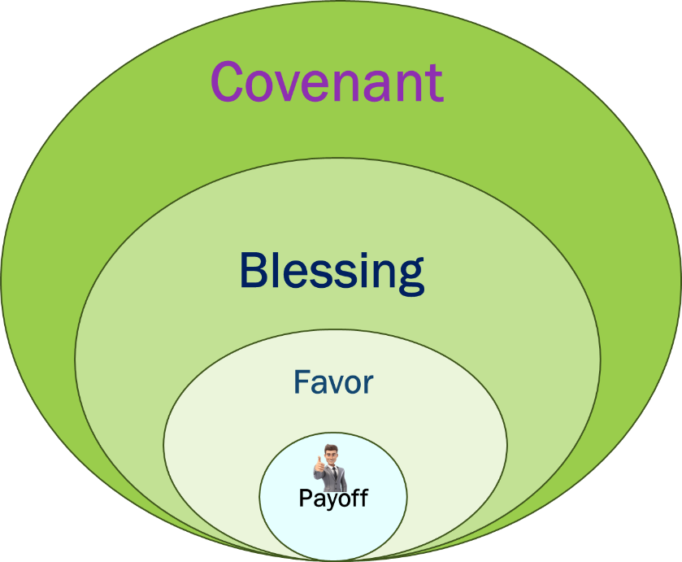

**Praise the Lord!**